# CS 499 Module One Assignment Template

Complete this template by replacing the bracketed text with the relevant information.

1. **Self-Introduction:** Address all of the following questions to introduce yourself.
   1. How long have you been in the Computer Science program?

I have been enrolled in the Computer Science program with SNHU since 2018.

* 1. What have you learned while in the program? List three of the most important concepts or skills you have learned.

While in the Computer Science program I have learned data structures, various programming languages, and how operating systems work. In the data structures coursework I learned how to organize and store data efficiently and utilize structures such as arrays, lists, and trees. I have also learned a variety of programming languages such as Python, Java, and C+ which will be very helpful when working with different applications. I’ve also learned a great deal about operating systems such as Linux, Windows and Android app development.

* 1. Discuss the specific skills you aim to demonstrate through your enhancements to reach each of the course outcomes.

I aim to demonstrate my ability to write in multiple programming languages and write code that is effective, efficient and secure. I plan to demonstrate my ability to communicate effectively through my oral and written communications.

* 1. How do the specific skills you will demonstrate align with your career plans related to your degree?

I plan to continue working as a developer with my current employer. I believe the specific skills I will demonstrate will demonstrate to my employer that I am able to work on different projects within the company, as I have the knowledge and skills to work on a variety of areas such as programming and database management.

* 1. How does this contribute to the specialization you are targeting for your career?

While I am not targeting any specific specialization at this time, I believe this contributes to my overall knowledge and experience, and prepares me for a variety of projects that may be assigned to me. I plan to continue working in Specialty Insurance and this is where I will continue working with various programming languages, databases, and operating systems.

1. **ePortfolio Set Up:**
   1. Submit a **screen capture** of your ePortfolio GitHub Pages home page that clearly shows your URL.
      1. You already have a repository in GitHub where you uploaded projects in previous courses. Your ePortfolio will reside in GitHub but can link to work at other sites, such as Bitbucket.
   2. Use the GitHub Pages link in the Resource section for directions on:
      1. How to create your GitHub website and publish code to GitHub Pages
      2. Issues, such as adding links to other sites
   3. Paste a screenshot of your GitHub Pages home page with your URL clearly showing in the space below.

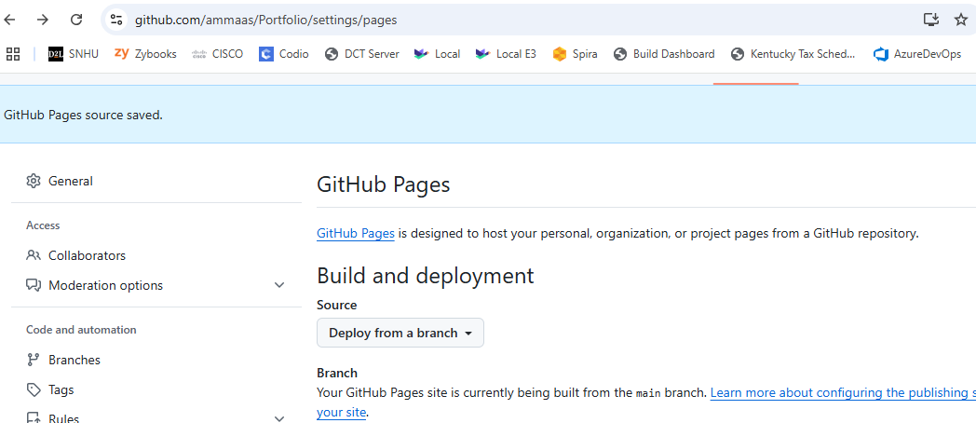

1. **Enhancement Plan:** 
   1. **Category One:** Software Engineering and Design
      1. **Select an** **artifact** that is **aligned with** **the** software engineering and design **category** and explain its origin. Submit a file containing the code for the artifact you choose with your enhancement plan.

I have selected the animal_shelter.py artifact from course CS 340, located here <https://github.com/ammaas/CS340> In this artifact I utilized Python to create a Create, Read, Update and Delete module to be utilized within a dashboard User Interface.

Note: Your artifact may be work from the following courses:

* IT 145: Foundation in Application Development
* CS 250: Software Development Lifecycle
* CS 260: Data Structures and Algorithms
* IT 315: Object Oriented Analysis and Design
* CS 320: Software Testing, Automation, and Quality Assurance
* CS 330: Computational Graphics and Visualization
* CS 340: Advanced Programming Concepts
* CS 350: Emerging Systems Architectures and Technologies
* CS 360: Mobile Architecture and Programming
* IT 365: Operating Environments
* IT 380: Cybersecurity and Information Assurance
* CS 405: Secure Coding
* CS 410: Reverse Software engineering
* IT 340: Network and Telecommunication Management
* IT 380: Cybersecurity and Information Assurance
  + 1. **Describe** a practical, well-illustrated **plan** for enhancement in alignment with the category, including a pseudocode or flowchart that illustrates the planned enhancement.

To demonstrate my ability to write in multiple programming languages, I will create a new Create, Read, Update, and Delete module in the Java programming language.

For this category of enhancement, consider improving a piece of software, transferring a project into a different language, reverse engineering a piece of software for a different operating system, or expanding a project’s complexity. These are just recommendations. Consider being creative and proposing an alternative enhancement to your instructor.

Think about what additions to include to complete the enhancement criteria in this category. Since one example option is to port to a new language, that is the kind of scale that is expected. This does not mean you need to port to a new language but instead have an equivalent scale of enhancement. Underlying expectations of any enhancement include fixing errors, debugging, and cleaning up comments, but these are not enhancements themselves.

* + 1. Explain how the planned enhancement will **demonstrate** specific **skills** and align with course outcomes.
       1. Identify and describe the specific skills you will demonstrate that align with the course outcome.

Software design and development requires problem solving, planning, and defining how the software will be organized and work. I will be demonstrating my ability to plan and write code in multiple coding languages.

* + - 1. Select one or more of the course outcomes below that your enhancement will align with.

This aligns with course outcome number 1: Employ strategies for building collaborative environments that enable diverse audiences to support organizational decision-making in the field of computer science; and course outcome number 2: Design, develop, and deliver professional-quality oral, written, and visual communications that are coherent, technically sound, and appropriately adapted to specific audiences and contexts.

Course Outcomes:

1. Employ strategies for building collaborative environments that enable diverse audiences to support organizational decision-making in the field of computer science.
2. Design, develop, and deliver professional-quality oral, written, and visual communications that are coherent, technically sound, and appropriately adapted to specific audiences and contexts.
3. Design and evaluate computing solutions that solve a given problem using algorithmic principles and computer science practices and standards appropriate to its solution while managing the trade-offs involved in design choices.
4. Demonstrate an ability to use well-founded and innovative techniques, skills, and tools in computing practices for the purpose of implementing computer solutions that deliver value and accomplish industry-specific goals.
5. Develop a security mindset that anticipates adversarial exploits in software architecture and designs to expose potential vulnerabilities, mitigate design flaws, and ensure privacy and enhanced security of data and resources.
   1. **Category Two:** Algorithms and Data Structures
6. **Select an artifact** that is **aligned with the** algorithms and data structures **category** and explain its origin. Submit a file containing the code for the artifact you choose with your enhancement plan. You may choose work from the courses listed under Category One.

I have selected the coursework from CS340 located here: <https://github.com/ammaas/CS340/blob/main/ProjectTwoDashboard.ipynb>

1. **Describe** a practical, well-illustrated **plan** for enhancement in alignment with the category, including a pseudocode or flowchart that illustrates the planned enhancement.

There are various features for an interactive data table to make the user interface user friendly. I plan to enhance this section to add additional features for sorting and filtering to improve the user experience.

For this category of enhancement, consider improving the efficiency of a project or expanding the complexity of the use of data structures and algorithms for your artifact. These are just recommendations. Consider being creative and proposing an alternative enhancement to your instructor. Note: You only need to choose one type of enhancement per category.

Think about what additions to include to complete the enhancement criteria in this category. Since one example option is to port to a new language, that is the kind of scale that is expected. Perhaps you might increase the efficiency and time complexity of an algorithm in an application and detail the logic of the increased time complexity. Remember, you do not need to port to a new language but instead have an equivalent scale of enhancement. Underlying expectations of any enhancement include fixing errors, debugging, and cleaning up comments, but these are not enhancements themselves.

1. Explain how the planned enhancement will **demonstrate** specific **skills** and align with course outcomes.
   1. Identify and describe the specific skills you will demonstrate to align with the course outcome.

This demonstrates my ability to apply algorithmic principles to design choices that improve the user experience within a user interface.

* 1. Select one or more of the course outcomes listed under Category One that your enhancement will align with.

This aligns with course outcome number 3: Design and evaluate computing solutions that solve a given problem using algorithmic principles and computer science practices and standards appropriate to its solution while managing the trade-offs involved in design choices; and course outcome number 4: Demonstrate an ability to use well-founded and innovate techniques, skills, and tools in computing practices for the purpose of implementing computer solutions that deliver value and accomplish industry-specific goals.

* 1. **Category Three: Databases**
     1. **Select an artifact** that is **aligned with the** databases **category** and explain its origin. Submit a file containing the code for the artifact you choose with your enhancement plan. You may choose work from the courses listed under Category One.

I have selected the coursework from CS340 located here: <https://github.com/ammaas/CS340/blob/main/ProjectTwoDashboard.ipynb>

* + 1. **Describe** a practical, well-illustrated **plan** for enhancement in alignment with the category, including a pseudocode or flowchart that illustrates the planned enhancement.

For my enhancement, I plan to add authentication to prevent unauthorized users from making changes to the database.

For this category of enhancement, consider adding more advanced concepts of MySQL, incorporating data mining, creating a MongoDB interface with HTML/JavaScript, or building a full stack with a different programming language for your artifact. These are just recommendations; consider being creative and proposing an alternative enhancement to your instructor. Note: You only need to choose one type of enhancement per category.

Think about what additions to include to complete the enhancement criteria in this category. Since one example option is to port to a new language, that is the kind of scale that is expected. Perhaps you might increase the efficiency and time complexity of an algorithm in an application and detail the logic of the increased time complexity. Remember, you do not need to port to a new language but instead have an equivalent scale of enhancement. Underlying expectations of any enhancement include fixing errors, debugging, and cleaning up comments, but these are not enhancements themselves.

* + 1. Explain how the planned enhancement will **demonstrate** specific **skills** and align with course outcomes.
       1. Identify and describe the specific skills you will demonstrate that align with the course outcome.

This demonstrates my skill to develop software that is safe and secure.

* + - 1. Select one or more of the course outcomes listed under Category One that your enhancement will align with.

This aligns with course outcome number 5: Design a security mindset that anticipates adversarial expoits in software architecture and designs to expose potential vulnerabilities, mitigate design flaws and ensure privacy and enhanced security of data and resources.

1. **ePortfolio Overall Skill Set**
   1. Accurately describe the **skill set** to be illustrated by the **ePortfolio** **overall**.
      1. Skills and outcomes planned to be illustrated in the code review

I will demonstrate my ability to follow coding best practices, critical thinking, knowledge of various programming languages, and effective communication skills

* + 1. Skills and outcomes planned to be illustrated in the narratives

In the narrative I plan to illustrate my ability to provide a well crafted description to showcase my work and abilities.

* + 1. Skills and outcomes planned to be illustrated in the professional self-assessment

I will illustrate my professional strengths and abilities as they pertain to computer science and programming. I will also be illustrating my communication skills and course achievements.